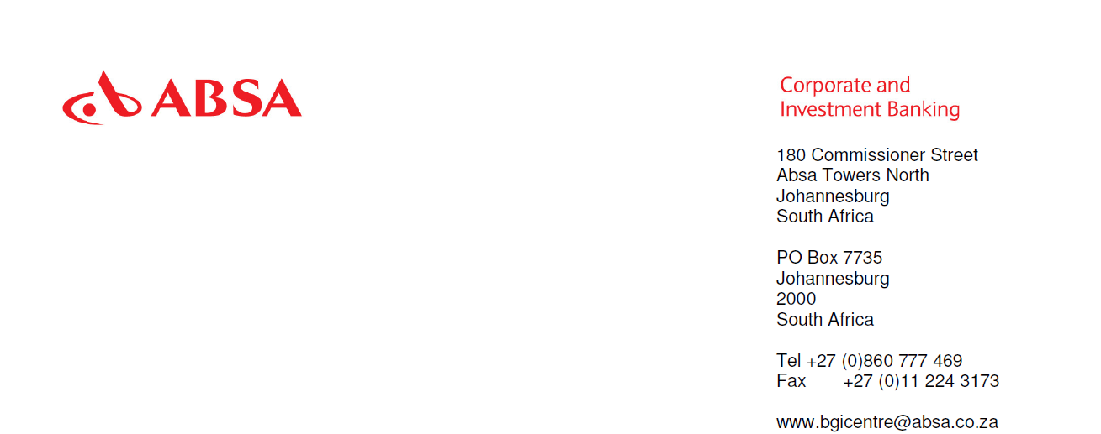

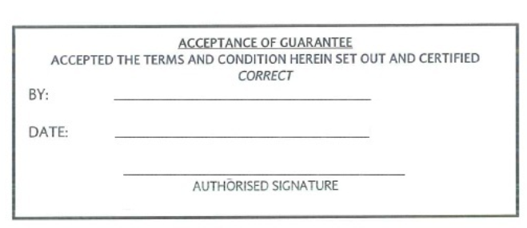

SWIFT-MT : 760 NORMALSWIFT-DEST : AXISINBBSENT TO : AXIS BANK LIMITEDMAKER TOWERS F FLOOR 13CUFFE PARADE, COLABA, MUMBAI400 005 INDIA:27: SEQUENCE OF TOTAL1/2:20: TRANSACTION REFERENCE NUMBER175-02-0143229-G:23: FURTHER IDENTIFICATION:REQUEST:30: DATE150203:40C: APPLICABLE RULESURDG:77C: DETAILS OF GUARANTEE:AT THE REQUEST OF OUR CLIENT, RAGNAR LODBROK TECHNOLOGIES (PROPRIETARY)LIMITED, PLEASE ISSUE THORUGH YOUR HYDERABAD BRANCH.APERFORMANCE GUARANTEE FOR THE AMOUNT.OF USD18,000.00 (EIGHTEENTHOUSAND UNITED STATES DOLLARS AND ZERO CENTS) TO THE BENEFICIARY, BJORN IRONSIDE ELECTRONICS CORPORATION OF INDIA LIMITED AS PER THE FORMAT BELOW:.

QUOTE

.

TO:BJORN IRONSIDE ELECTRONICS CORPORATION OF INDIA LIMITEDIT AND TG — PURCHASE DEPARTMENTECIL POST, HYDERABAD - 500062AP, INDIA.

AT THE REQUEST OF RAGNAR LODBROK TECHNOLOGIES (PROPRIETARY) LIMITED, WEAXIS BANK LIMITED, HYDERABAD BRANCH ISSUE THE FOLLOWING GUARANTEE IN YOUR FAVOUR

.

BANK GUARANTEE NUMBER (XXXXXXXXXX)AMOUNT OF GUARANTEE: USD18,000.00 (EIGHTEEN THOUSAND UNITED STATES DOLLARS AND ZERO CENTS)GUARANTEE COVER FROM 07 JULY 2016 TOLAST DATE OF CLAIM PERIOD 15 FEBRUARY 2017.

THIS DEED OF GUARANTEE EXECUTED BY AXIS BANK LIMITED, HYDERABADA BODY CORPORATE CONSTITUTED UNDER THE MAKER 400 005 INDIA ANDAMONGST OTHER PLACES A BRANCH AT BEGUMPET ROAD, HYDERABAD(HEREINAFTER CALLED 'THE BANK') IN FAVOUR OF BJORN IRONSIDE ELECTRONICSCORPORATION OF INDIA, IT AND TG - PURCHASE DEPARTMENT, ECIL POST,.

HYDERABAD “ 500062, AP, INDIA (HEREINAFTER CALLED 'ECIL') FOR ANAMOUNT NOT EXCEEDING USD18,000.00(EIGHTEEN THOUSAND UNITED STATES DOLLARS AND ZERO CENTS) AT THE REQUEST OF M/S GEW TECHNOLOGIES (PROPRIETARY) LIMITED,HAVING ITS REGISTERED OFFICE IN SOUTH AFRICA (HEREINAFTER CALLED'THE SUPPLIER') IN THE PURCHASE ORDER IN RESPECT OF WHICH THEBANK GUARANTEE IS BEING SUBMITTED ACCORDING TO THE TERMS ANDCONDITIONS COVERING AND ANNUAL REPAIR CONTRACT AS SECURITY TOCOMPLETE THE WORK AND PROVIDE THE SERVICE WITHIN STIPULATED TIME..THE BANK HEREBY UNDERTAKES TO PAY TO THE ECIL AN AMOUNT NOTEXCEEDING USD18,000.00 (EIGHTEEN THOUSAND UNITED STATES DOLLARS AND ZERO CENTS) BY REASON OF BREACH OF AGREEMENT 'TERMS AND CONDITIONS' AS STATED IN AND COMMITMENTUNDER THE SCOPE OF PURCHASE ORDER..ANY SUCH DEMAND MADE BY THE ECIL IN WRITING SHALL BE CONCLUSIVEAND BINDING ON THE BANK IRRESPECTIVE OF ANY DISPUTE(S) ORDIFFERENCE(S) RAISED BY THE GUARANTOR..

THE PAYMENT SO MADE BY THE BANK UNDER THIS BOND SHALL BE VALIDDISCHARGE OF LIABILITY FOR PAYMENT THERE UNDER AND THE GUARANTORSHALL HAVE NO CLAIM AGAINST THE BANK MAKING SUCH PAYMENT..THIS GUARANTEE WILL NOT BE DISCHARGED DUE TO THE CHANGE IN THECONSTITUTION OF THE BANK OR GUARANTOR..

THIS GUARANTEE SHALL BE IRREVOCABLE AND SHALL REMAIN VALID UP TO6 MARCH 2017. THE GUARANTEE SHALL BE EXTENDED FURTHER AT THEDISCRETION OF THE BANK FOR SUCH PERIOD AS REQUIRED UNDER THEINSTRUCTIONS OF THE SUPPLIER, I.E M/S GEW TECHNOLOGIES(PROPRIETARY) LIMITED, ON WHOSE BEHALF THIS GUARANTEE ISFURNISHED..IN ORDER TO GIVE FULL EFFECT TO THE PROVISIONS OF THIS GUARANTEETHE BANK HEREBY WAIVES ALL RIGHTS INCONSISTENT WITH THE ABOVEPROVISIONS AND WHICH THE BANK MIGHT OTHERWISE AS A GUARANTOR BEENTITLED TO CLAIM AND ENFORCE..WE, AXIS BANK LIMITED RENEW THE BANK GUARANTEE AT OUR DISCRETIONPROVIDED THE REQUEST FOR RENEWAL IS MADE BY THE GUARANTIOR BEFORETHE EXPIRY OF THE BANK GUARANTEE WITH THE NUTUAL CONSENT OF THEBANK OR GUARANTOR. WE, AXIS BANK LIMITED LASTLY UNDERTAKE NOT TOREVOKE THIS GUARANTEE DURING THE CURRENCY EXCEPT WITH THEPREVIOUS CONSENT OF THE ECIL IN WRITING .ND THE GUARANTEE SHALLBE CONTINUOUS AND IRREVOCABLE GUARANTEE UP TO A SUM OFUSD18,000.00 (EIGHTEEN THOUSAND UNITED STATES DOLLARS AND ZERO CENTS)..

NOTWITHSTANDING ANYTHING STATED HEREINBEFORE..

I. THE BANK'S LIABILITY UNDER THIS GUARANTEE SHALL NOT EXCEEDUSD18,000.00 (EIGHTEEN THOUSAND UNITED STATES DOLLARS AND ZERO CENTS) AND.

II. THIS GUARANTEE SHALL BE VALID UPTO 15 JANUARY 2017 (THEEXPIRY DATE INCLUDING CLAIM PERIOD) AND.III WE ARE LIABLE TO PAY THE GUARANTEED AMOUNT OR ANY PARTTHEREOF UNDER THIS BANK GUARANTEE ONLY AND ONLY IF YOU SERVE UPONUS A WRITTEN CLAIM OR DEMAND ON OR BEFORE 15 JANUARY 2017 (THEEXPIRY DATE INCLUDING CLAIM PERIOD).

IV THEREAFTER THE BANK SHALL STAND DISCHARGED FROM ALL ITSLIABILITY UNDER THIS GUARANTEE AND ALL YOUR RIGHTS UNDER THISGUARANTEE SHALL STAND EXTINGUISHED, IRRESPECTIVE OF THE FACTWHETHER THE GUARANTEE IN ORIGINAL IS RETURNED BACK TO US ORNOT..

UNQUOTE.

IN CONSIDERATION OF YOU ISSUING THE ABOVE BANK GUARANTEE, WE,ABSA BANK LIMITED HEREBY UNDERTAKE TO INDEMNIFY YOU AGAINST ANYPAYMENT RESULTING FROM YOU DOING SO PROVIDED THAT OUR LIABILITYIN TERMS THEREOF SHALL NOT EXCEED IN AGGREGATE A MAXIMUM AMOUNTOF USD18,000.00 (EIGHTEEN THOUSAND UNITED STATES DOLLARS AND ZERO CENTS). THE SAID AMOUNT SHALL BE PAID TO YOU IN TERMS OF YOUR INSTRUCTIONS DESPITE ANYCONTESTATION BETWEEN ALL PARTIES CONCERNED AGAINST RECEIPT OFYOUR REQUEST BY TESTED TELEX/AUTHENTICATED SWIFT CONFIRMININGTHAT YOU HAVE BEEN CALLED UPON TO MAKE PAYMENT IN TERMS OF THEAFORESAID GUARANTEE AND HAVE IN FACT MADE SUCH PAYMENT..

REVISION..

ALL CHARGES OUTSIDE OF SOUTH AFRICA SHALL BE FOR THE ACCOUNT OFTHE SUPPLIER (RAGNAR LODBROK TECHNOLOGIES PROPRIETARY LIMITED).

.PLEASE CONTACT THE FOLLOWING ONCE YOUR GUARANTEE IS READY FORCOLLECTION AT YOUR COUNTERSMR S. SRIKANTH BJORN IRONSIDE ELECTRONICS INDIA EMPLOYEE ID GEWE/IlMOBILE NO. +91 90522 66650 OR OFFICE NO. +91 404222 1030/31

.THIS IS THE OPERATIVE INSTRUMENT AND NO MAIL CONFINMATION WILLFOLLOW..

KIND REGARDS, ABSA BANK BGI CENTRE